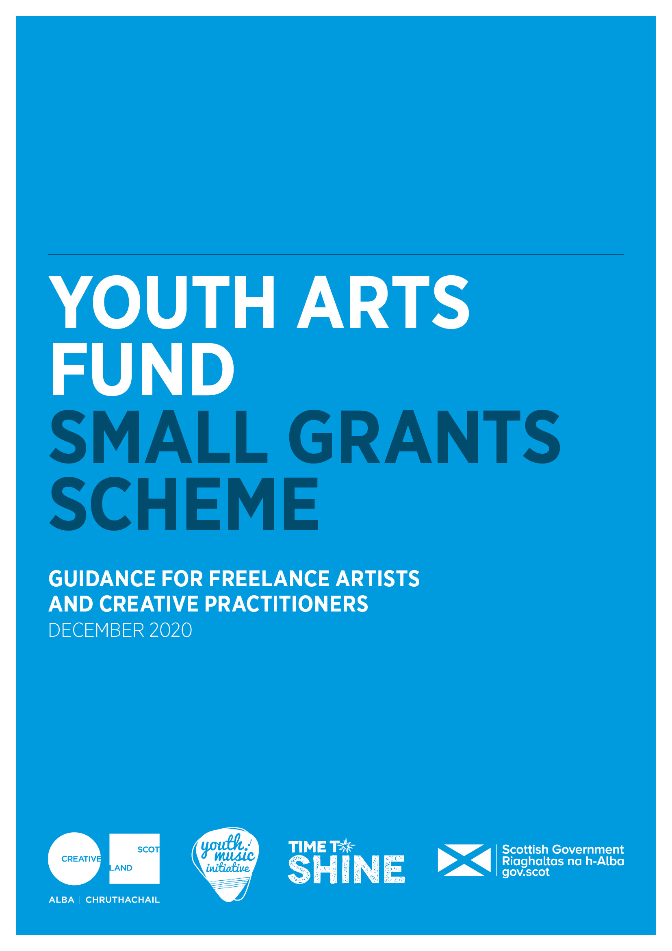

**Youth Arts Small Grants Scheme**

**Guidance for Freelance Artists and Creative Practitioners**

**Wheatley Foundation**

The purpose of this guidance is to support you, as a freelance artist, to apply for funding. The guidance accompanies the Small Grants Freelance Artists and Creative Practitioners Application Form.

**Background**

The [Youth Arts Small Grants Scheme](https://www.creativescotland.com/funding/funding-programmes/youth-arts-fund) is part of a Scottish Government Covid-19 Funding Package to support the arts, administered by Creative Scotland.

A number of organisations across Scotland have been awarded ‘funding pots’ through the Small Grants Scheme to distribute small grants to freelance artists, to work with children and young people across Scotland.

The grants aim to create work opportunities for freelance artists and creative practitioners and provide arts activities for children and young people, especially those most affected by Covid-19.

**Who can apply and how much can you apply for?**

This fund is open to freelance artists and creative practitioners living and working in Scotland looking to work directly with children and young people.

The fund is not open to applications from organisations, local authorities, groups or clubs.

The overall budget for this fund is £50,000.00 Applicants can apply for between £500 -£5,000 to deliver projects. All projects must be completed by the end of March 2022.

**Alternative formats, languages and access support**

Wheatley Foundation, part of Wheatley Housing, is committed to supporting applications in other formats. If you need to apply for funds in an alternative format, or you need support to make your application please contact:

Dermot Lynch, Foundation Officer

[Dermot.lynch@gha.org.uk](mailto:Dermot.lynch@gha.org.uk)

07786 190764

**Filling out Your Application**

**Section A: Key Information**

This section asks for your contact details, and some summary information about your project. It also asks you for the start and end date of your project and where your project will take place. Make sure that you build in planning time and some time to reflect on your project at the end.

In the ‘artform you will work in’ box ‘Wider Arts’ means any artform that is not music. We need this information for monitoring purposes.

Please also ensure you confirm that you have read through the guidance in this section.

**Section B: Supporting Information**

All artists must include separate documents listed as supporting material.

If you don’t provide these your project will not be eligible for support.

You should include the supporting documents as email attachments with your application.

These include:

* **A copy of your current CV.** This helps us to understand what you have achieved so far in your practice, your training and track record. You may also include your artist statement
* **Evidence of your PVG scheme membership**
* **Letters or emails of support from partners organisations** outlining support and their involvement in the project where relevant

Any letters of support should state the need for the project, how the partner will work with you to ensure the project is a success, and that they are ready and able to support you to work with children and young people.

**Section C: Skills and Experience**

The small grants scheme sets out to fund youth arts practitioners who have both strong and appropriate skills in their artform and in working with children and young people.

In this section of the application, you can outline the skills and experience you have that relate to your project. You can show how you have gained these skills by telling us about relevant training and similar projects you have run.

You may want to use a bullet point list to summarise these – we will also have your CV for information.

**Section D: Project Details**

What are the needs related to young people and how will you cater for these during your project? Have you worked with this group of young people before?

Let us know how children and young people will join the project and how you see the project positively supporting and helping young people.

We would also like to hear about children and young people having their voices heard, so they can influence the project.

In this section you should also let us know about the activity you are planning with young people. Let us know how many children and young people are likely to take part in the different activities you will offer.

All activities must be provided free to children and young people.

**Your project timeline**

The project timeline should outline key activities and milestones. Include time and milestones for planning, building relationships, marketing, evaluating and sharing in your project timeline.

All your project activity must be completed by the end of March 2022, including evaluation and reporting on your project.

**Small Grants Scheme Priority Groups**

The Youth Arts Small Grants Scheme aims to support children and young people in a range of priority groups. These groups are listed below and in the application form. In the application form question you should delete all those you are not going to work with.

Wheatley Foundation will match you to our partner groups supporting the identified areas. You should indicate how you will work collaboratively with the groups to support children/young people.

Applications that show they can work with one or more of these groups will be prioritised for funding.

The Small Grants Scheme priority groups are young people:

* living in poverty or areas of social and economic deprivation. *For more information on the Scottish Index of Multiple Deprivation (SIMD) please visit the*[*Scottish Government website*](https://www.gov.scot/collections/scottish-index-of-multiple-deprivation-2020/)*.*
* experiencing or at risk of experiencing harm and neglect
* who are looked after *(as defined by the Children (Scotland) Act 1995) and care leavers (as defined by the Children and Young People (Scotland) Act 2014). For more information please visit the*[*Scottish Government website*](https://www.gov.scot/policies/looked-after-children/)*.*
* from Black and/or Minority Ethnic backgrounds
* who have a disability and/or additional support needs
* at risk of offending or have previously offended
* who are young carers (as defined by the Carers (Scotland) Act 2016) and/or young parents
* experiencing or at risk of homelessness, or who have been homeless
* experiencing mental ill health

**Locations**

Wheatley Foundation will match successful applicants to partners within their communities. As part of the training/networking provision, successful applicants will have time and opportunities to meet them, make contact and plan out first steps.

Please tick the relevant boxes to indicate the area(s) you will deliver your project idea in.

**Making sure people can participate**

Inequality means that children and young people may experience both physical and psychological barriers to taking part in activities. It is important to think through potential barriers and how to create equal access to the project.

* Will young people think that the project is for them?
* Will they have access to any digital equipment needed?
* Who can support young people to participate and how will you reach them?

It may be helpful to talk this through with project partners before completing your application.

**Planning and working with your partner organisation**

Due to Covid-19 restrictions, it is more important than ever to plan carefully with partners to ensure that they are ready to work with you. For example, project partners could be schools, youth or community groups or other artists/ creative practitioners you plan to work with. Wheatley Foundation will match up successful artists/practitioners to partners like this who are working in our communities.

We would like to hear about any planning you may have done so far with partner organisations, and how you will approach working together with our local community partners.

It would be helpful to understand what your roles will be in the project.

We would like to hear what your collective goals are for the project and how you envisage the partner organisation will help you recruit and support children and young people.

**Reflecting and evaluating with your partner organisation**

In this section we would like to understand how you and your partner organisation will take time to stop and reflect on progress during the project and how you will evaluate the project together.

Please tell us about when you will reflect and your methods for exploring whether the project is a success.

**Section E: Budget**

Your budget should include income and a breakdown of your project expenditure.

The income section should state the grant requested from the Small Grants Scheme, any other sources of funding. Please indicate if these are cash or in-kind contributions and ensure in-kind is accounted for in both income and expenditure.

You can apply for 100% of your project costs through this application, however including other income (cash or in-kind) can strengthen a proposal. A partner organisation may, for example, be contributing staff time to the project. This can be listed as an in-kind contribution.

Please make sure that you let us know the daily rate you and other artists are paid. Please note, artists must be paid at industry rates. You can find further information on the [Creative Scotland website](https://www.creativescotland.com/resources/our-publications/funding-documents/rates-of-pay-guidance).

Expenditure can include artists fees, equipment and resources to complete the project. Equipment should not account for more than 15% of your project grant.  It is good practice to include a project contingency of approximately 5%.

Remember to include fees for your participation in Wheatley Foundation training/networking, equating to 2 days.

**Section F: Risk Assessment**

When considering risk, you will need to think about Covid-19 related risks, all other risks to the project and safeguarding children and young people. You can consult the [Scottish Government](https://www.gov.scot/) website for the latest information about restrictions and arrangements for working in school and community settings in light of Covid-19.

Examples are given below:

|  |  |  |  |
| --- | --- | --- | --- |
| **What general risks you have identified?** | Risk level before managing risk | **How will you manage this risk?** | Risk level after managing risk |
| **General risks** | | | |
| Safeguarding issues with a group of young people joining a ZOOM meeting | High | Follow NSPCC and SCVO guidance on safeguarding on ZOOM including using a waiting room, password protection and disabling the chat function between group members | Low |
| **Covid-19 related risks** | | | |
| Area moves to level 4 Lockdown and youth groups will not allow artist in the building | High | Alternatives planned for including use of project packs and virtual alternatives for meeting. | Low |

**Networking and training activity**

Networking and training are an important element of the Youth Arts Small Grants Scheme. Please indicate in this section whether you are available to attend the network and training sessions provided by Wheatley Foundation.

Wheatley Foundation will organise up to 2 days of training and networking for successful artists/practitioners, followed by monthly networking Zoom sessions to keep in touch, share successes and experiences.

**What happens to your application?**

Your application will go through a selection process.

It will only be eligible to be considered for funding if you have filled out all sections and have attached the supporting documents to your email.

An eligibility check will also cover whether you are working with the priority groups and are an artist working with children and young people to deliver youth arts activity.

The application process consists of:

|  |  |
| --- | --- |
| Key dates | Date |
| The deadline for making an application is: | 5pm 5th  March 2021 |
| Assessment process  Decision Process Assessment panel  The panel will be made up of  Wheatley Foundation Team Officers  Wheatley Community Engagement Officers  Creative Scotland Representative | Week beginning 22nd March |
| Decisions communicated to applicants: | Mon 29th March – Wed 31st March 2021` |
| Funds distributed: | Instalments as agreed with first instalments by July 2021 |
| Project Completion.  (this is the latest date for completion of projects)  End of Project Reporting due: | 31st March 2022  15th March 2022 |

**Evaluation and reporting**

Wheatley Foundation will provide an End of Project Monitoring Form at early stages in order to ensure you are prepared to collect the relevant qualitative and quantitative information required by us and Creative Scotland to report on your project. We will also liaise with you on your monitoring plans from the outset/during the project.

**Use of Your Information**

Wheatley Foundation will use the information contained in this form solely for the intended reason it was gathered in relation to the Small grants Fund. All copies, physical and electronic, will be destroyed 12 months after the closing date if the applicant is unsuccessful. Wheatley Foundation’s Privacy Notice and Small grants statement can be found here:

<https://www.wheatley-group.com/home/privacy-notices/wheatley-foundation/wheatley-foundation-privacy-statement>