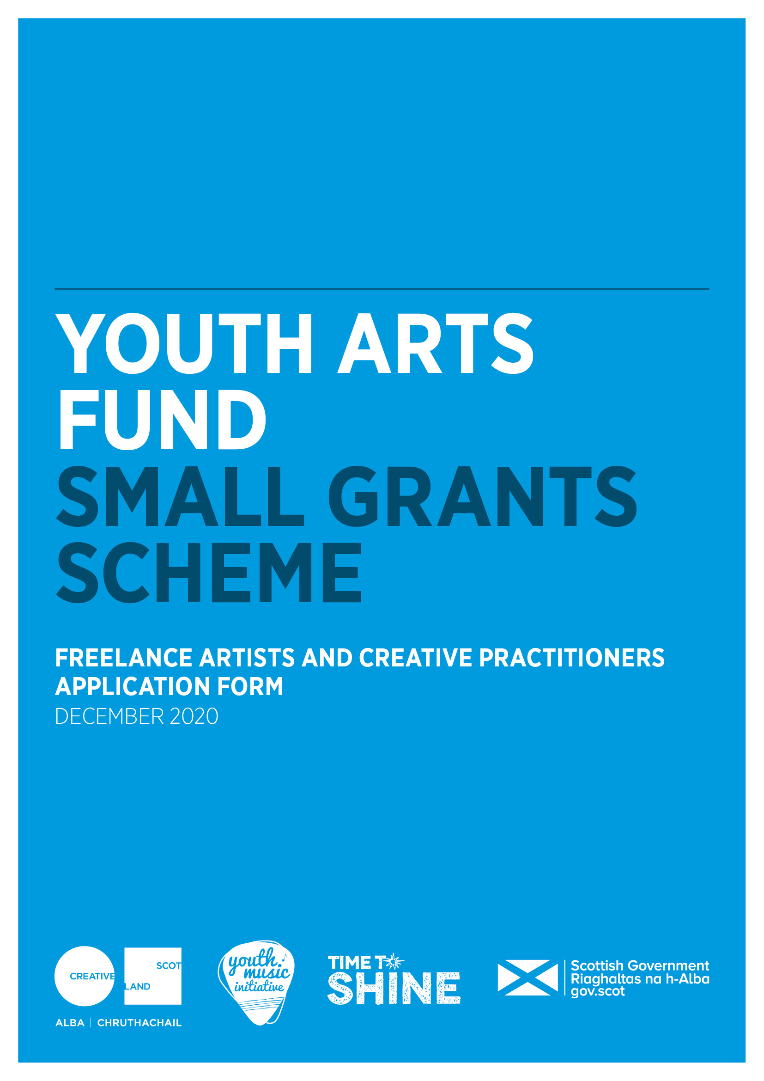



**Youth Arts Small Grants Scheme**

**Freelance artists and creative practitioners**

**Application form**

**Wheatley Foundation**

Please ensure that you have read the Small Grants Guidance for Freelance Artists and Creative Practitioners carefully before completing the form.

**Section A: Key Information**

|  |  |
| --- | --- |
| **Name** |  |
| **Address** |  |
| **Postcode** |  |
| **Contact telephone number(s)** |  |
| **Email** |  |
| **Website** |  |
| **Start date of your project** |  |
| **End date of your project** |  |
| **Amount of funding requested** |  |

|  |  |  |
| --- | --- | --- |
| **Names of any schools, youth, community groups and other organisations you are working in partnership with** |  | |
| **Number of children and young people you aim to work with** |  | |
| **Age range of children and young people you aim to work with** |  | |
| **Main artform you will work in**  please indicate the main artform you will work in by placing an X in the relevant box | **Music** | **Wider Arts (other than music)** |
|  |  |
| **Number of days work this project will support you to undertake** |  | |

**Section B: Supporting Information**

|  |  |
| --- | --- |
| **Supporting information** | **Submitted (please mark with an X)** |
| **Please submit a copy of your current CV**  This helps us to understand what you have achieved so far in your practice, your training and track record. You may also submit your artist statement if you have one. |  |
| **Please submit evidence of your PVG scheme membership** |  |
| **Please submit letters or emails of support from partners organisations** outlining support and their involvement in the project |  |

**Section C: Skills and Experience**

**Please tell us about your work as a youth arts practitioner**

What kind of work do you do with children and young people? What are your key skills and experience that mean you can do the work well? *300 words max*

|  |
| --- |
|  |

**Section D: Project Details**

**Please tell us about the project you want to apply for**

Please include:

* the need for the project
* how you see this project positively supporting and helping children and young people
* opportunities for children and young people to have their voices heard
* a description of the activities including number, content and duration of sessions

*400 words max*

Please note: all project activity must be provided free of charge to children and young people.

|  |
| --- |
|  |

**Please provide a project timeline**outlining key dates and milestones. Information can be presented in bullet point format.

|  |
| --- |
|  |

**Are you planning to work with children and young people in the following priority groups?** Please tick all groups that you plan to work with.

|  |  |
| --- | --- |
| **Priority group** | **Please tick** |
| **Those living in poverty or areas of social and economic deprivation.** For more information on the Scottish Index of Multiple Deprivation (SIMD) please visit the [**Scottish Government website**](https://www.gov.scot/collections/scottish-index-of-multiple-deprivation-2020/) |  |
| **Are experiencing or at risk of experiencing harm and neglect** |  |
| **Are looked after** (as defined by the Children (Scotland) Act 1995) and care leavers (as defined by the Children and Young People (Scotland) Act 2014). For more information, please visit the [**Scottish Government website**](https://www.gov.scot/policies/looked-after-children/) |  |
| **Are from Black and/or Minority Ethnic backgrounds** |  |
| **Have a disability and/or additional support needs** |  |
| **Are at risk of offending or have previously offended** |  |
| **Are young carers** (as defined by the Carers (Scotland) Act 2016) and/or young parents |  |
| **Are experiencing or at risk of homelessness, or who have been homeless** |  |
| **Are experiencing mental ill health** |  |

Wheatley Foundation will match successful projects to partners in our communities. Please identify which area(s) you are proposing to work in.

|  |  |
| --- | --- |
| **Location** | **Tick preferred area(s) below:** |
| Glasgow East |  |
| Glasgow West |  |
| Glasgow South |  |
| Paisley |  |
| Stirling |  |
| Edinburgh |  |
| Dumfries and Galloway |  |

**Please tell us how you are going to engage with children and young people in the priority groups and area(s) you have chosen.** *300 words max*

|  |
| --- |
|  |

**Please tell us what barriers to participation children and young people might experience, and how you will work with partners to make sure that young people can take up the proposed opportunity.** *300 words max*

|  |
| --- |
|  |

**Please tell us how you plan to work together with partner organisations** to support children and young people. *200 words max.*

|  |  |
| --- | --- |
|  | |
| **Have you previously worked with community organisations supporting young people?** | Yes/ no |
|  | |

**Please tell us how you will reflect on the work with the children and young people and partner organisations and how you will know if it has been successful?** *300 words max*

|  |
| --- |
|  |

**Section E: Budget**

Please provide a budget breakdown for your project, detailing the grant requested, your own financial contribution and any other sources of funding if applicable. Please indicate if these are cash or in-kind contributions and ensure in-kind is accounted for in both income and expenditure.

Please include provision for two days training/networking within your budget. Participation is required as part of the Small Grants process. Your time participating will be paid at industry rate.

Please note, artists/creative practitioners must be paid at industry rates. You can find further information on the [Creative Scotland website](https://www.creativescotland.com/resources/our-publications/funding-documents/rates-of-pay-guidance).

|  |  |  |
| --- | --- | --- |
| **Expenditure** - breakdown of estimated project costs (including hourly rate used) | | |
| **Item** | **Cost (£)** | **Cash or in-kind** |
|  |  |  |
|  |  |  |
|  |  |  |
|  |  |  |
|  |  |  |
|  |  |  |
|  |  |  |
| **Total cost of project** |  |  |

|  |  |  |
| --- | --- | --- |
| **Income** – total should equal your expenditure above | | |
|  | **£** | **Confirmed**  **Cash or in-kind** |
| **Grant request from Small Grants Scheme** |  |  |
| **Other sources of income, including in-kind**  **(if applicable)** |  |  |
| **Total estimated income for project** |  |  |

**Section F: Risk Assessment**

**Please tell us about project risks and how you will manage them**

**Please fill in risk level: *high, medium*** *or* ***low*** *before and after managing the risk*

|  |  |  |  |
| --- | --- | --- | --- |
| **What general risks you have identified?** | Risk level before managing risk | **How will you manage this risk?** | Risk level after managing risk |
| **General risks** | | | |
|  |  |  |  |
|  |  |  |  |
|  |  |  |  |
|  |  |  |  |
| **Covid-19 related risks** | | | |
|  |  |  |  |
|  |  |  |  |
|  |  |  |  |
|  |  |  |  |

**Networking and training activity**

Networking and training are an important part of the Youth Arts Small Grants Scheme. Please indicate in below whether you are available to attend network and training sessions provided by our organisation. These may be online.

|  |  |  |  |
| --- | --- | --- | --- |
| **Please confirm your intention to attend the planned training to support your project** | | | |
| **Yes** |  | **No** |  |

**Use of Your Information**

Wheatley Foundation will use the information contained in this form solely for the intended reason it was gathered in relation to the Small grants Fund. All copies, physical and electronic, will be destroyed 12 months after the closing date if the applicant is unsuccessful. Wheatley Foundation’s Privacy Notice and Small grants statement can be found here:

<https://www.wheatley-group.com/home/privacy-notices/wheatley-foundation/wheatley-foundation-privacy-statement>

I hereby confirm that the information in this application submission including the supporting documents is true and correct and I acknowledge that it is my responsibility to inform you immediately of any changes which could affect the interpretation or context of the application, and I confirm I will undertake to do this.

……………………………………………

Applicant signature

……………………………………………

Date  

**Please submit your completed application to:**

**Dermot Lynch,**

**Wheatley Foundation Officer**

Dermot.lynch@gha.org.uk